# Lab 6 – Files: Random Numbers

You will create each program in the IDLE environment and save it as a python file. Use the file naming convention *yourlastname*_Lab6.*n.*py where “n” is the exercise number.

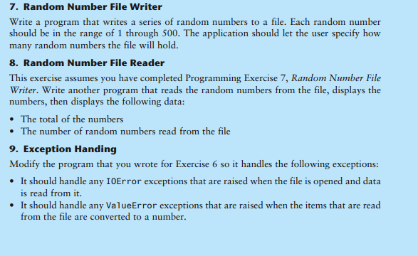

**Problem 8 should also display the average of the random numbers.**

**Exception Handling**: Both programs should use Try and Except Clauses to handle IOError, ValueError, and unspecified error exceptions. Be sure to test your programs for invalid cases. For example , try running the second program to read the file when it doesn’t exist or manually put bad data in the file and see what happens.

**Programming Style Requirements.**

* Comments – Begin your program with a comment that includes: a) your name, b)program status – either “Complete” or describe any incomplete or non-functioning part of your program c)A 1-3 line description of what the program does.
* Function comments – each function should begin with a comment explaining what the function does
* Variable names – use meaningful variable names such as total_taxes or num_cookies.
* Function names – use meaningful verb names for functions such as display_taxes.
* Named constants – Use named constants for all number values that will not be changed in the program such as RECIPE_SUGAR = 1.5. See section 2.9 on Named Constants

You should have 2 program files to turn in.